**Resolving conflicts**

Conflicts will normally occur when you try to merge a branch that may have competing changes. Git will normally try to automatically merge (auto-merge), but in the case of a conflict it will need some confirmation, the competing changes need to be resolved by the end user. This process is called merging or rebasing.

The developer must look at the changes on the server and the changes on their local and validate which changes should be resolved.

A merge conflict example is when two developers are working on their own dependent branches. Both developers are working on the same file called Feature.js. Each of their tasks is to add a new feature to an existing method. Developer 1 has a branch called feature1 and developer 2 has a branch called feature2.

Developer 1 pushes the code with the changes to the remote repository. Developer 2 pushes their changes.

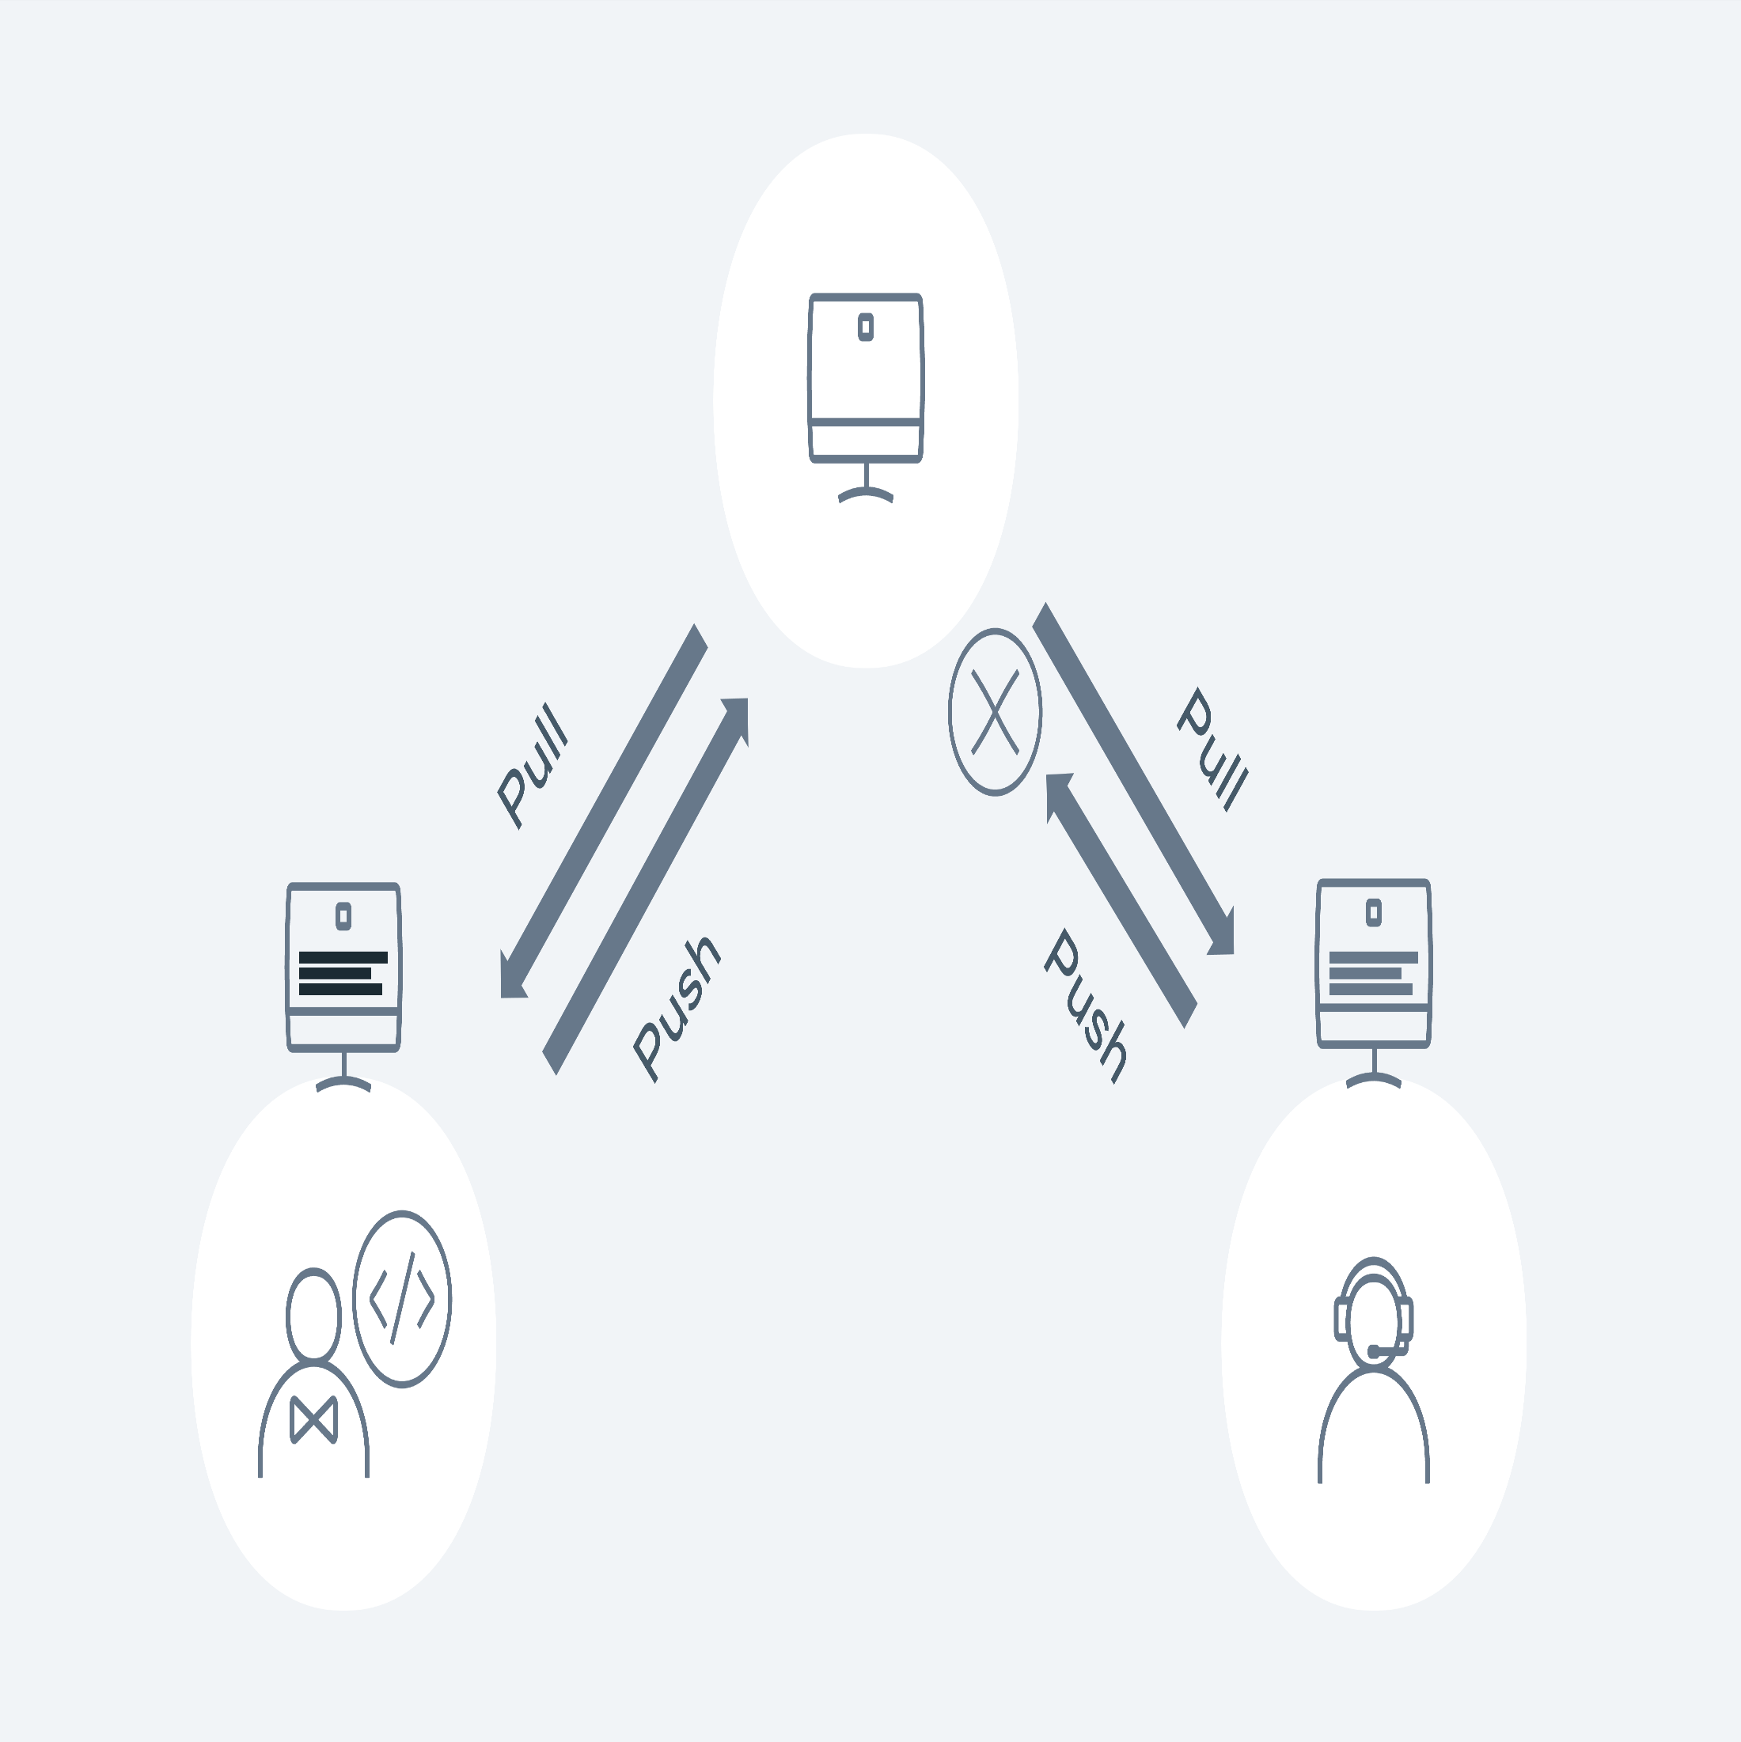Demonstration of the push pull method

Let's walk through how this would happen in Git. Both developers 1 and 2 checkout the main repository on Monday morning. They both have the exact same copy. Both developers checkout a new branch - feature 1 and 2.

1

2





1

2





Developer 1 makes their changes to a file called Feature.js and then commits the changes to the repository for approval via a PR (pull request)

1

2

3

4





The PR is reviewed and then merged into the main branch. Meanwhile Developer 2 is starting to code on his feature. Again, they go through the same process as Developer 1:

1

2

3

4

5

6

7

8

9

10





Git lets us know that a merge conflict has occurred and needs to be fixed before it can be pushed to the remote repo. Running git status will also give us the same level of detail:

1

2

3

4

5

6

7

8

9

10

11





In order to merge, Developer 2 needs to see and compare the changes from Developer 1. It is good practice to first see what branch is causing the merge issue. Developer 1 runs the following command:

1

2

3

4

5

6

7

8

9

10

11

12

13

14

15





We can see from the above that the team conflicting changes occurred in feature 1 and 2 branches. Developer 1 now wants to see the change that is causing the conflict.

1

2

3

4

5

6

7

8

9

10

11

12

13

14

15

16





The only difference is the wording in the return statement. Developer 1 added 'too much' but Developer 2 added 'way too much. Everything else is identical so in terms of merging and it's a pretty easy fix. Git will show arrows <<< >>> to signify the changes. Developer 1 removes the markers so the code is ready for being submitted:

1

2

3

4





1

2

3





Developer 2 has now fixed a merge conflict and can create their PR to get the code merged into the main line.

………………………………………………………………………………………………………

git pull

git checkout -b feature1

git pull

git checkout -b feature2

git add Feature.js

git commit -m 'chore: added feature 1!!'

git pull origin main

git push -u origin feature1

git add Feature.js

git commit -m 'chore: added feature 2!!!'

git pull origin main

From github.com:demo/demo-repo

* branch main -> FETCH_HEAD

9012934..d3b3cc0 main -> origin/main

Auto-merging Feature.js

CONFLICT (content): Merge conflict in Feature.js

Automatic merge failed; fix conflicts and then commit the result.

git status

On branch feature2

You have unmerged paths.

(fix conflicts and run "git commit")

(use "git merge --abort" to abort the merge)

Unmerged paths:

(use "git add <file>..." to mark resolution)

both modified: Feature.js

no changes added to commit (use "git add" and/or "git commit -a")

git log --merge

commit 79bca730b68e5045b38b96bec35ad374f44fe4e3 (HEAD -> feature2)

Author: Developer 2

<developer2@demo.com>

Date: Sat Jan 29 16:55:40 2022 +0000

chore: add feature 2

commit 678b0648107b7c53e90682f2eb8103c59f3cb0c0

Author: Developer 1

<developer1@demo.com>

Date: Sat Jan 29 16:53:40 2022 +0000

chore: add feature 1

git diff

diff --cc Feature.js

index 1b1136f,c3be92f..0000000

--- a/Feature.js

+++ b/Feature.js

@@@ -1,4 -1,4 +1,8 @@@

let add = (a, b) => {

++<<<<<<< HEAD

+ if(a + b > 10) { return 'way too much'}

++=======

+ if(a + b > 10){ return 'too much' }

++>>>>>>> d3b3cc0d9b6b084eef3e0afe111adf9fe612898e

return a + b;

}

let add = (a, b) => {

if(a + b > 10) { return 'way too much'}

return a + b;

}

git add Feature.js

git commit -m 'fix merge conflicts'

git push -u origin feature2